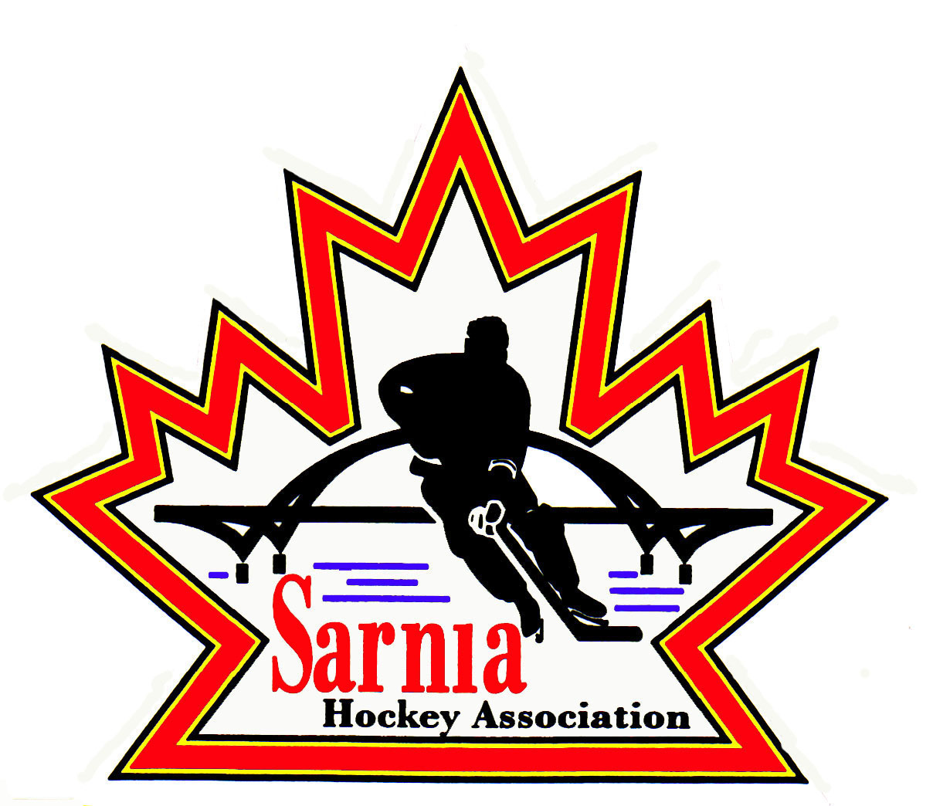

Sarnia Hockey Association

Minutes | Date: JUNE 4, 2024 | time 7:00 pm

Meeting called by | Paul Walsh, President
Type of meeting | Regular
Secretary | Kelly Lane, Recording Secretary

Welcome | Paul Walsh, President and meeting Chair welcomed everyone and called the meeting to order at 7:04 pm.

ATTENDANCE | Jerry Bernardo, Emily Brown, Darren Chevalier, Ian Dunn, Jeff Fogal, Pat Forbes, Kelly Lane, Kyle Mellor, John Mellor, Jeffrey Needham, Wayne Scarrow, Lesley Taylor-Smith, Kevin Taylor, Tim Turner, Barb Walsh, Paul Walsh  Regrets: Andrew Beasley, Jacquie Beasley, Chuck Ewart, Terry Gray, Linda Lauzon, Bonny Marcy, Don McGugan, Ted Pendle, David Penner  Guest: John Ritchie

ACCEPTANCE OF MINUTES | MOTION #240604-001  “That the Minutes from May 22, 2024, be accepted as presented.” (L. Smith-Taylor/E. Brown)  Carried

TREASURER’S REPORT | UPDATE FROM LAST MEETING:  Bank accounts for A/AA are finally underway. Sign off by team signing officials has taken place.  Meetings will be with the bank and team signing officials so bank accounts can be officially opened.  B/BB accounts will not be open until after the teams are formed.  FINANCIAL STATEMENTS:  Extra lines have been added as it provides more transparency.  Not a lot of activity in the month of May.  Some expenses in May were from previous season.  Tryout and prep ice amounts were small as most registered in April.  Under expenses – Alliance team entry fees will be attributed to next season.  Coach and annual meetings – some coaches haven’t cashed cheque yet.  Ice – some ice costs from last season.  MOTION #240604-002  “That the Treasurer’s Report be accepted as presented.” (E. Brown/J. Mellor)  Carried  COZY COMMITTEE:  A group of individuals known as the “Cozy Committee” identified SHA as their charity of choice for a golf tournament that are running. They have collected $17,000 so far. Use of the funds will focus on rec league goalie development again as well as supporting those players in need with equipment. We will be partnering with community agencies such as YMCA, Big Brother, Big Sisters etc.  The Cozy Committee is asking SHA to post the golf tournament and sponsorship information on our website. It does not conflict with the Face off for Mental Health golf tournament. They haven’t sold out yet. We need an adult and child volunteer to assist.  REP ASSESSMENT FEES:  A change has been made on how we collect these fees. Previously teams collected the funds from parents and then the team paid SHA at the end of November. Now parents can pay through HCR. There will be another registration piece so that parents can pay SHA directly via etransfer or credit card. This can be done in 3 installments. It will open in late September. We will give a time limit so that parents can take advantage of installments. Emails will be sent out a few days prior to when installment is due. We have used this during registration, and it worked well. This change has been communicated to the rep teams. We have not received any negative feedback and Managers have thanked us as it takes away the responsibility of them chasing payments.  HCR is a great tool to have and an easy platform.

BILLS TO BE PAID | MOTION #240604-003  “That the bills be paid as presented.” (E. Brown/Dunn)  Carried
  Recipient | Expense | Amount
  City of Sarnia | Jamboree Ice  Prep Skates  Tryout Ice  Meeting rentals | $ 17,719.00  $16,091.00  $19, 362.00  $504.00

REGISTRAR | Registration ready to go and launches on June 10.

REP REPORTS | A/AA tryouts are complete and B/BB U10-U16 tryouts are ongoing.  A coaches meeting occurred for B/BB U10-U16 coaches and A/AA coaches that missed their first meeting.  It was an online meeting, and it went well. Coaches had lots of questions. Vice President Administration, Vice President Rep Teams, Treasurer, Registrar, A/AA and B/BB Directors, Rep Equipment Director participated in the meeting. Ice Director sent comments that were read out.  This was a first set of coach meetings to get everyone going for tryouts and tournament prep. At next meeting will be going over the July 10 deadline and some responsibilities for regular season to be covered off.  In the meantime, we are going through policy revisions so that it is a stronger message from the Association for our policies.  Rep Equipment Director set up the Fit Night at the Honey Pot for players to get fitted for jerseys and socks. One will be set up for BB when tryouts are completed. Fit night for Ice Authority can be set up for any teams wanting team apparel through them. They can do it through Ice Authority or Team Outfitters who are official vendors for Sting apparel.  June 21 – next set of interviews for U8/9 and U18 B/BB and MD teams for fall tryouts. Coach interviews on June 21 and June 22.

REC VICE CHAIR | We still need a U15 Convener and a Foundations convenor. We have 2 candidates. We will appoint the U15 Convener at our next meeting (June 19). We are still looking for Foundations and Blake Morrison has reached out to some parents requesting volunteers. We will post the Foundations request for a convener about a month after registration.

ICE DIRECTOR | Lots of issues coming up regarding ice especially black out weekends.  U17 World Championships are in Sarnia which will take away our ice availability at PASA. The City is still working on the final black out list. Stars on Ice want the first weekend in December. City has our request for black out weekends, so we have to wait and see. We are the largest consumer of ice. We can’t move the Silver Stick tournament as we have 26 teams booked. Ice Scheduler will reach out to the City and so will SHA President.  PASA 1 won’t be ready until July. PASA 2 is now open.

CLINIC DIRECTOR | Looking at late August for a D1 Clinic. Ice Scheduler is booking room and looking at ice availability. Once we have that locked down, we will get an Instructor from the Alliance. Registrar will also let Rec coaches know as well once we have a date. We will likely get coaches from out of town which will help offset our costs.  There is a need for C1 and C2, but Alliance doesn’t have it open.  ACTION ITEM: Clinic Director to reach out to Alliance regarding this.

NEW BUSINESS | SUMMER SKATE CAMP:  We can’t run it this year as we could not secure a stable ice schedule. If we try to do this again, we need to start planning in January.  SPAM EMAILS  Some spam emails being sent out on behalf of SHA President. If it is important, the SHA President will call directly. The incorrect email address is generally the clue that the email is spam.  NEXT MEETING:  Next meeting is Wednesday, June 19, 2024, at 7:00 pm at Clearwater Arena Lower Hall.

adjournment | MOTION #240604-004  “That the meeting be adjourned.” ( E. Brown/Scarrow)  Carried

Paul Walsh Kelly Lane
President Secretary

